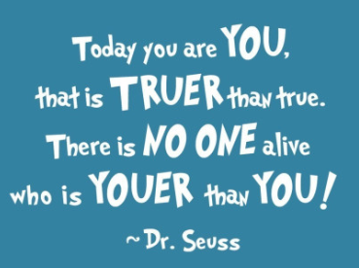
5/6 Home Assignment 1
There are 2 parts to this assignment:
Part A) Mixed Media Self-Portrait
You are to create a piece of art work, which is a self-portrait of you. Remember that this is ART - not just a picture/photo of you. You may like to think about using different mediums (materials), and think about the style you would like to create.
Here are some websites that might inspire you:
https://www.hellowonderful.co/post/12-CREATIVE-SELF-PORTRAIT-ART-PROJECTS-FOR-KIDS
https://artprojectsforkids.org/category/view-by-theme/portrait/
# If you google, mixed media self-portraits and look at images, you will see a huge variety of examples to inspire you!
Part B) – My Precept
A precept can be described as a rule, a motto, a quote, or a saying, that can motivate or help guide people to make important decisions, or to behave in a certain way. In the movie, Mr Browne asks the students a very important question; ‘What kind of person are you?’ He introduces a new precept every month for the students to discuss and to think about, as they learn about what type of person they are.
The second part of your self-portrait assignment is to include a separate poster with a precept which means something to you, or that you can relate to. On the back of your precept poster, I want you to write a one paragraph explanation of what your precept means and why you chose it.
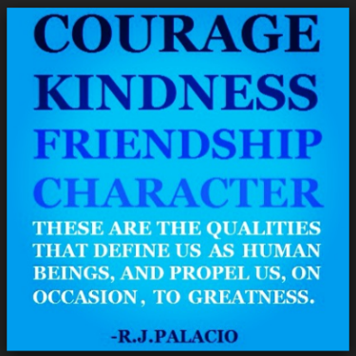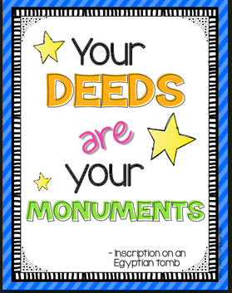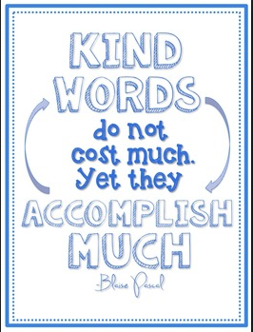
Important Information – Requirements & things to Consider…
- You MUST complete your art work and precept poster on the paper given to you at school (just see me if you need spare sheets).
- Your self-portrait and poster must be able to be hung up on the back wall.
- Your self-portrait can be realistic, or it can be quite abstract and Picasso-like. It is NOT important that it looks exactly like you, but it must represent you. And as you can see from examples, some self-portraits include relevant words or other images that may relate to you.
- Remember, this is art. It is hard to get it wrong or to make a mistake, as you are the artist. Use this as an opportunity to get creative; to stretch your creativity; and to have fun!
- If you need any equipment, ideas or any help along the way, come and speak to me, but please don’t leave it until the last minute to come and see me. Also, If you have any printing (say a photo or picture, or your precept poster), bring it in on a flash drive so that you can print it at school, and save your ink at home!
- Like all good artists, sign your self-portrait in a corner or space somewhere.
- You will allocated a mark/grade for this assignment. Please look at the success criteria carefully.
- You will lose 1 mark for every day that your assignment is late.
- Finally, your art work should take up most or all of the space on the page. Don’t make it too small and end up with lots of white space left. Use the images when you google, as a guide.
Learning Intentions & Purpose
- For students to create a piece of artwork for different audiences, assembling materials in a variety of ways. VAS3.2
- For students to connect their artwork to themselves and their world.
- For students to make a connection between themselves and an inspirational quote/precept, and to be able to explain/justify this connection.

This new learning is important so that students can:
- gain experience with expressing, responding and representing in critical and creative ways.
- identify a quote/precept that is meaningful to him/her and to critically reflect on it and its intended message.

Success Criteria

I am successful when: |  | High  4 | Sound  3 | Basic  2 | Limited  1
1 | My artwork represents a self-portrait.
2 | My self-portrait shows evidence of creativity.
3 | My artwork shows awareness of page space, layout and proportion.
4 | My precept is published, poster quality.
5 | My paragraph explains what I think the meaning of my precept is and why I chose it.
6 | My paragraph reflects senior primary writing skills (attention to spelling, punctuation, grammar, handwriting, etc).

Have fun & be creative!
Mrs B

