5-6 English Film Study - Term 1
Dear Parents/Carers,
Our English unit to start the year off with is titled, ‘Choose Kind’. It involves viewing, reading and discussing various texts on the themes of friendships, discrimination, respect for differences, and anti-bullying. As a component of this unit, we will be doing a character and film study of the recent movie, ‘Wonder’. As a class we will be researching and discussing some of the key concepts from the movie (disabilities, disorders, discrimination, bullying, etc), as well as learning and enhancing the student’s comprehension and reading/writing skills.
I have included a brief synopsis of the movie. Please return the note below if you give consent for your child to watch the movie, or feel free to speak to me if you have any questions or concerns about any aspects of our planned unit.

Regards,
Tracey Bromfield
5/6 Teacher
Based on the New York Times bestseller, WONDER tells the incredibly inspiring and heartwarming story of August Pullman. Born with facial differences that, up until now, have prevented him from going to a mainstream school, Auggie becomes the most unlikely of heroes when he enters the local fifth grade. As his family, his new classmates, and the larger community all struggle to discover their compassion and acceptance, Auggie's extraordinary journey will unite them all and prove you can't blend in when you were born to stand out.

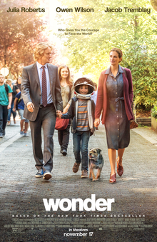

‘Wonder’ PG Movie Permission Note – Year 5/6

I give permission for my child _________________________, to watch the movie ‘Wonder’ (rated PG), in class during term 1, 2018. I understand that this is part of the planned English unit.

Signed: ____________________________ Date: __________________

